Case Study 2: Employee Payroll

1. Problem Statement
Calculate an employee's gross salary, deduction, and net salary.

2. Objectives
- Add basic pay and allowance.
- Subtract the deduction from gross salary.

3. Assumptions
- Allowance and deduction are entered as amounts.
- All amounts should be non-negative.

4. Algorithm
1. Read basic pay, allowance, and deduction.
2. Calculate gross = basic + allowance.
3. Calculate net = gross - deduction.
4. Display gross and net salary.

5. Flowchart
START → Input salary values → Validate → Calculate gross salary → Subtract deduction → Display result → STOP
For a drawn flowchart, use: oval for START/STOP, parallelogram for input/output, rectangle for calculations, and diamond for decisions.

6. Pseudocode
READ basic, allowance, deduction
gross = basic + allowance
net = gross - deduction
DISPLAY gross, net

7. Python Source Code
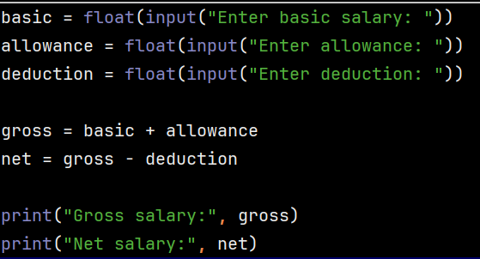

8. Test Cases
Test 1: 20000, 3000, 1000 → gross 23000, net 22000. Test 2: 15000, 1000, 500 → gross 16000, net 15500.

Sample Output
Input: Basic ₹20000, allowance ₹3000, deduction ₹1000
Output: Gross salary: 23000.0
Net salary: 22000.0

9. Conclusion
The program uses variables and arithmetic operators to prepare a simple salary statement.

